Reference Shelf Assembly Instructions
For Penco Clipper® and Erectomatic® Shelving

Step 1 – Check the contents of the hardware kit.
The kit should contain these pieces
(8) P/N 8632 10-24 x 3/8 Truss Screw (Attaches bracket to shelf)
(8) P/N 8672 10-24 Hex Nut
(4) P/N 8101 ¼-20 x 1 ¼ Truss Head Bolt (Attaches shelf to post)
(4) P/N 8473 ¼-20 Hex Nut
(4) P/N 8408 1 3/16 Square Washer (Use with Erectomatic post)

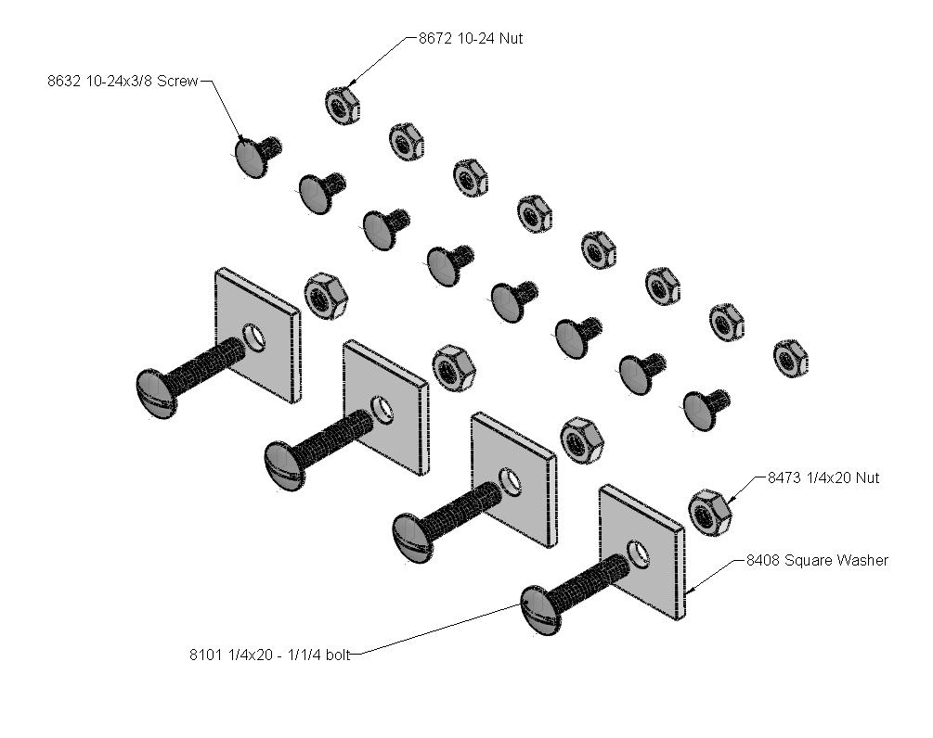

Step 2 – Secure the parent shelf in your shelving unit with bolts.

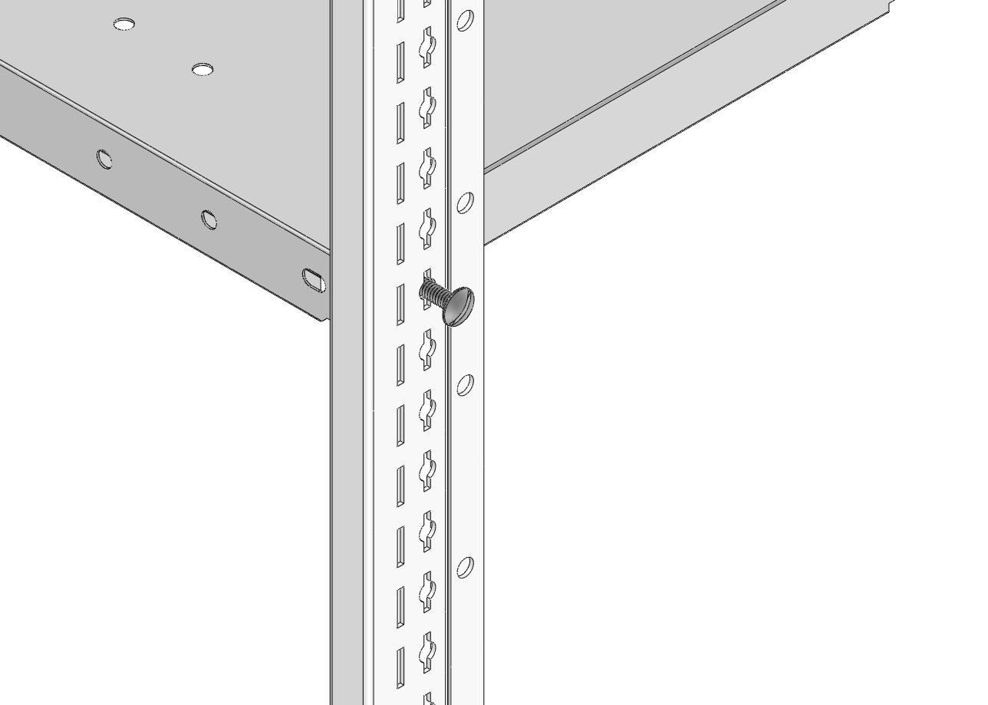
Identify the shelf in your shelving unit (not included in the reference shelf kit) where you want to attach the reference shelf. Fasten the shelf to the post on all four corners using the (4) 8101 bolts and 8473 hex nuts included in the hardware kit. If the shelving unit was assembled using clips to support the shelf these are to be removed. (If you are using Erectomatic posts skip to step 2a below)
Note: The sliding reference shelf can only be used with Clipper shelving when the front posts are box style posts.

Step 2a – Securing shelves on Erectomatic style posts.

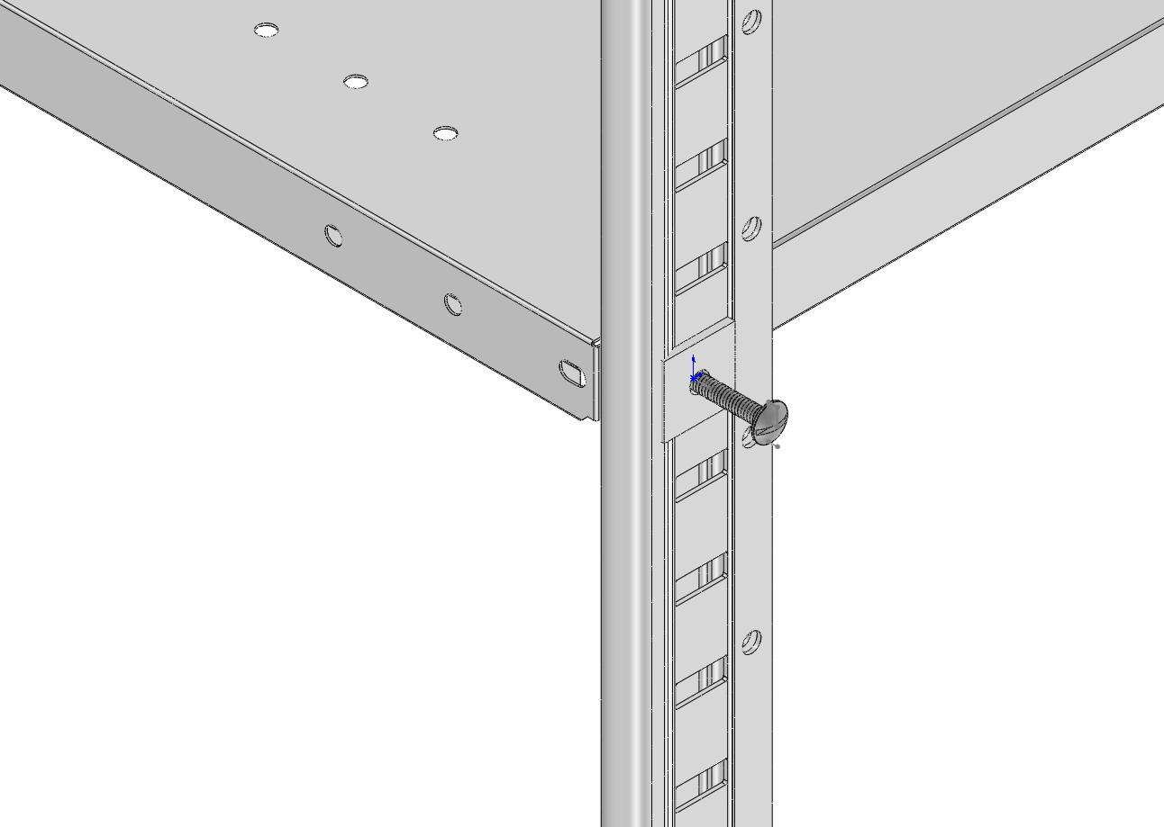
Bolt the shelf on all four corners as in step 2 above. Use the square washers (P/N 8408 from the hardware kit when locating the bolt on the post (see illustration below)

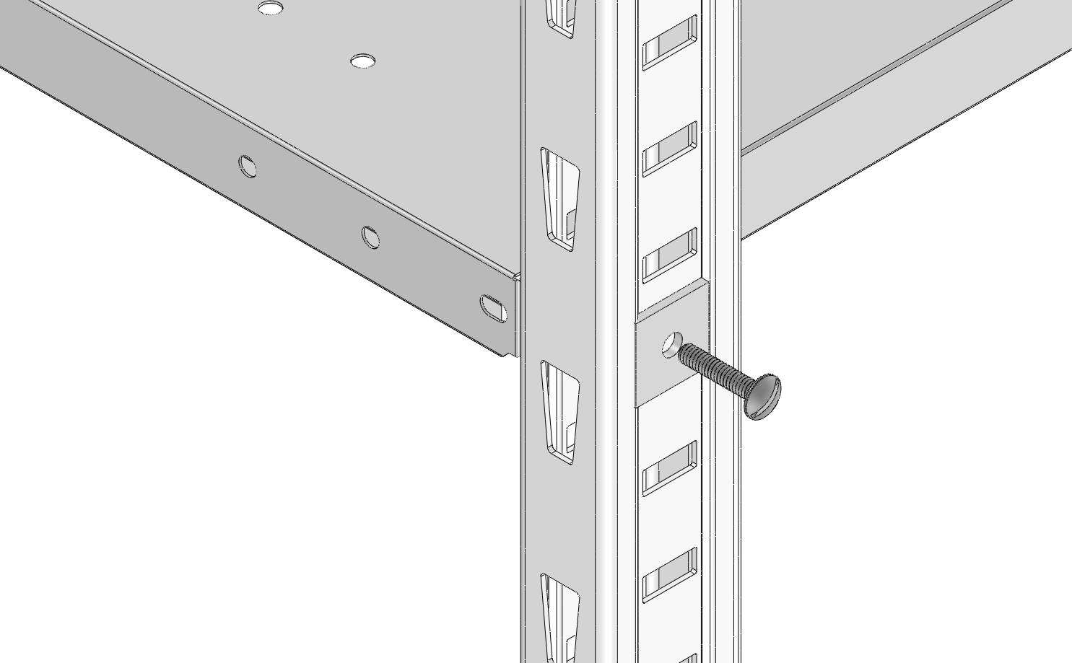

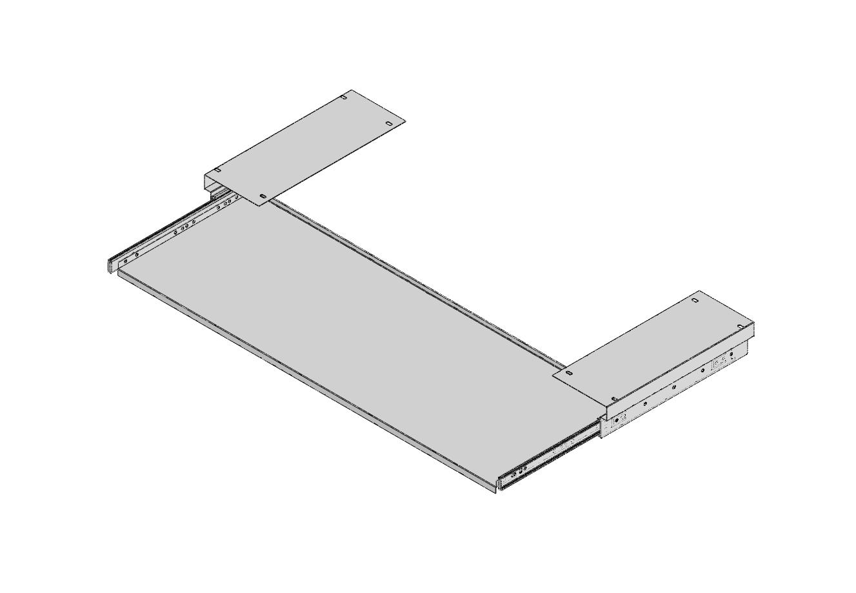

Step 3 - Release the reference shelf from its brackets

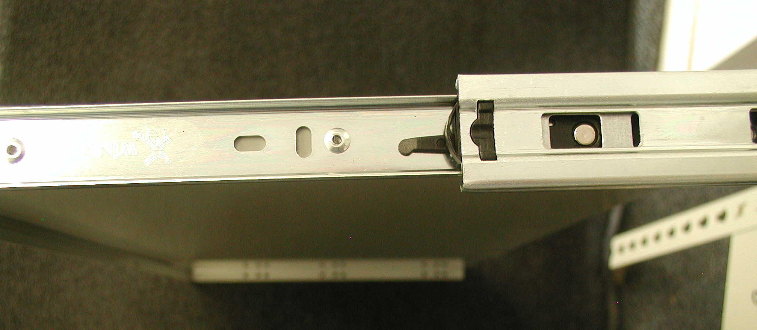
The reference shelf, mounting brackets, and glides are assembled at the factory. It will be easier to attach the unit to the parent shelf if the reference shelf is first separated from the two mounting brackets. This is easily done by sliding the mounting brackets away from the shelf by pushing them back. Now look at the extended slide on each side and you will find a small lever. Push this to release the inner slide from the rest of the glide assembly and slide the mounting bracket free from the shelving unit (the glide assembly separates into two pieces)

Release lever
Step 4 – Attach the brackets to the parent shelf.
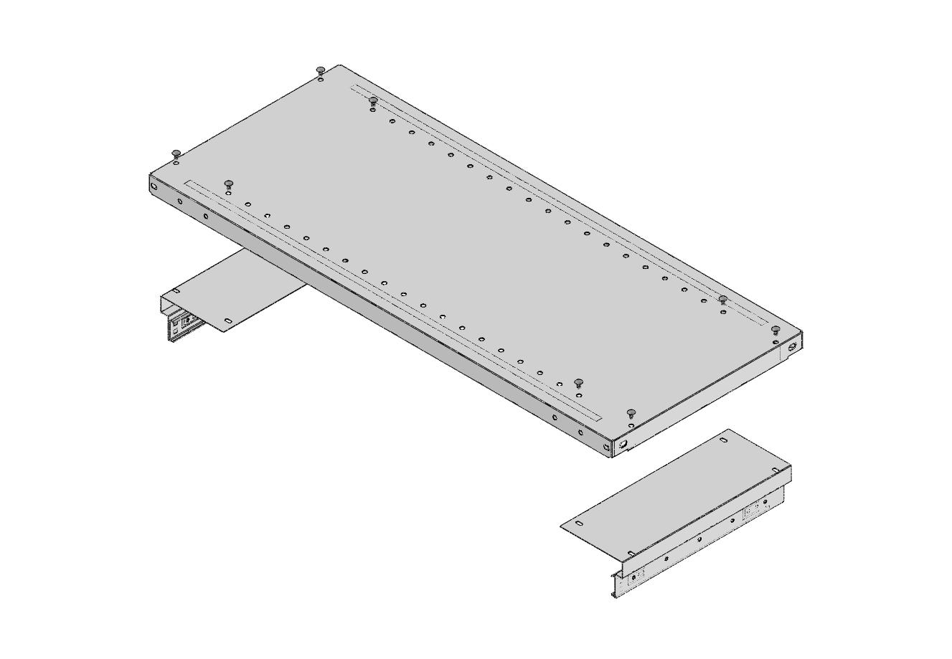
Bolt the brackets to the underside of the parent shelf you bolted into your shelving unit using the (8) 8632 screws and 8672 nuts. Do not tighten the nuts yet!

Step 5 – Reinsert the reference shelf into the glides and tighten nuts.

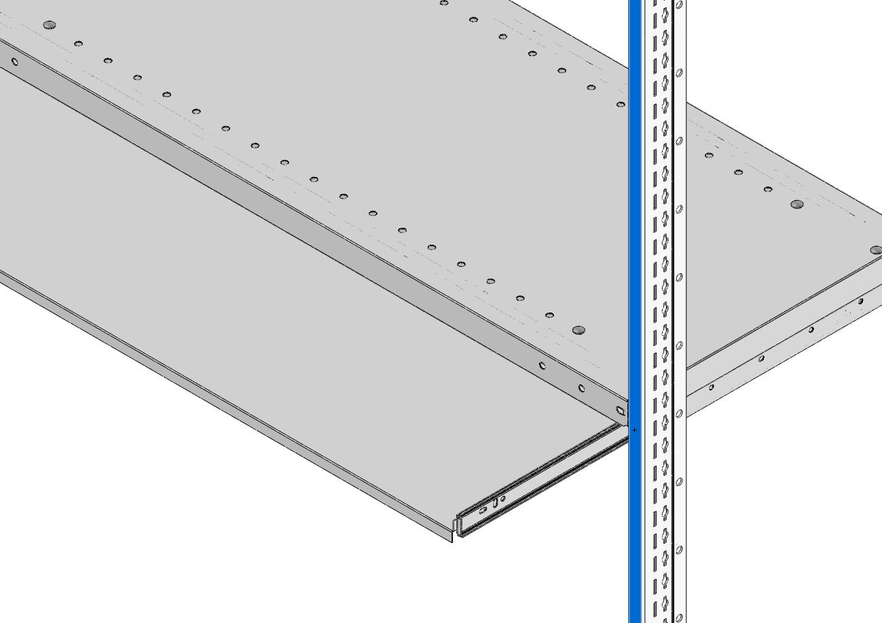
Slide the reference shelf back into the outer glides attached to the mounting brackets. Take care to properly align the mating pieces of the glide assembly to prevent damage to the glide assembly. Test the shelf to make sure the mounting brackets are parallel to each other and the shelf operates freely. Then finish tightening the nuts holding the brackets to the shelf.

PENCO PRODUCTS, INC. PHONE: 800-562-1000 FAX: 800-248-1555
E-MAIL: general@pencoproducts.com www.pencoproducts.com

Reference Shelf Instruction Sheet P/N: 10RS0ASSYDWG

